Abstract—RESUMO DO TRABALHO EM PORTUGUÊS
Título do Trabalho
Nome do Aluno, Nome do Orientador, Nome do Co-orientador

Index Terms—Enter key words or phrases in alphabetical order, separated by commas. For a list of suggested keywords, send a blank e-mail to keywords@ieee.org or visit http://www.ieee.org/organizations/pubs/ani_prod/keywrd98.txt

Introdução
Este documento é um modelo para os artigos a serem apresentados no Seminário de Metodologia Científica e Tecnológica para Engenharia Elétrica. Este modelo é baseado no template para submissão de trabalhos para revistas do IEEE (https://ieeeauthor.wpengine.com/create-your-ieee-article/use-authoring-tools-and-ieee-article-templates/ieee-article-templates/templates-for-transactions/). Os trabalhos devem possuir no máximo seis páginas e devem conter no mínimo as seguintes seções:

- Introdução
  - Qual o problema de Engenharia que será abordado
  - Qual a importância do mesmo para a área
  - Como tem sido resolvido
  - Objetivo do trabalho
- Aspectos teóricos
  - Definições, conceitos, regulamentações, etc
  - Revisão bibliográfica: detalhamento de como o problema tem sido abordado
- Metodologia proposta
  - Descrição da metodologia proposta
  - Hipóteses a serem investigadas
  - Delimitação dos possíveis estudos de caso a serem considerados
- Plano de trabalho para a disciplina TEE00172
  - Resultados esperados
  - Cronograma de trabalho
  - Produção associada

Caso o trabalho já possua algum resultado preliminar, a estrutura mínima proposta acima pode ser expandida para inclusão do estudo de caso considerado e apresentação dos resultados preliminares.

Aspectos Teóricos
Descrever aspectos teóricos.

Formatação para subseção
Utilizar este padrão para eventuais subseções dentro do artigo.

Segunda subseção
XXXX

Metodologia Proposta
Descrever metodologia.

Descrição das equações
Number equations consecutively with equation numbers in parentheses flush with the right margin, as in (1). First use the equation editor to create the equation. Then select the “Equation” markup style. Press the tab key and write the equation number in parentheses. To make your equations more compact, you may use the solidus ( / ), the exp function, or appropriate exponents. Use parentheses to avoid ambiguities in denominators. Punctuate equations when they are part of a sentence, as in

(1)

Be sure that the symbols in your equation have been defined before the equation appears or immediately following. Italicize symbols (T might refer to temperature, but T is the unit tesla). Refer to “(1),” not “Eq. (1)” or “equation (1),” except at the beginning of a sentence: “Equation (1) is ... .”

Plano de Trabalho para a Disciplina TEE00172
Descrever metodologia.

Descrição de Figuras
Vide abaixo descrição de como inserir Figuras, Gráficos e Tabelas.

TABLE I
Units for Magnetic Properties
Symbol | Quantity | Conversion from Gaussian and  CGS EMU to SI ª
Φ | magnetic flux | 1 Mx → 10⁻⁸ Wb = 10⁻⁸ V·s
B | magnetic flux density,  magnetic induction | 1 G → 10⁻⁴ T = 10⁻⁴ Wb/m²
H | magnetic field strength | 1 Oe → 10³/(4π) A/m
m | magnetic moment | 1 erg/G = 1 emu  → 10⁻³ A·m² = 10⁻³ J/T
M | magnetization | 1 erg/(G·cm³) = 1 emu/cm³  → 10³ A/m
4πM | magnetization | 1 G → 10³/(4π) A/m
σ | specific magnetization | 1 erg/(G·g) = 1 emu/g → 1 A·m²/kg
j | magnetic dipole  moment | 1 erg/G = 1 emu  → 4π × 10⁻¹⁰ Wb·m
J | magnetic polarization | 1 erg/(G·cm³) = 1 emu/cm³  → 4π × 10⁻⁴ T
χ, κ | susceptibility | 1 → 4π
χ_{ρ} | mass susceptibility | 1 cm³/g → 4π × 10⁻³ m³/kg
μ | permeability | 1 → 4π × 10⁻⁷ H/m  = 4π × 10⁻⁷ Wb/(A·m)
μ_{r} | relative permeability | μ → μ_{r}
w, W | energy density | 1 erg/cm³ → 10⁻¹ J/m³
N, D | demagnetizing factor | 1 → 1/(4π)
Vertical lines are optional in tables. Statements that serve as captions for the entire table do not need footnote letters.
ªGaussian units are the same as cg emu for magnetostatics; Mx = maxwell, G = gauss, Oe = oersted; Wb = weber, V = volt, s = second, T = tesla, m = meter, A = ampere, J = joule, kg = kilogram, H = henry.

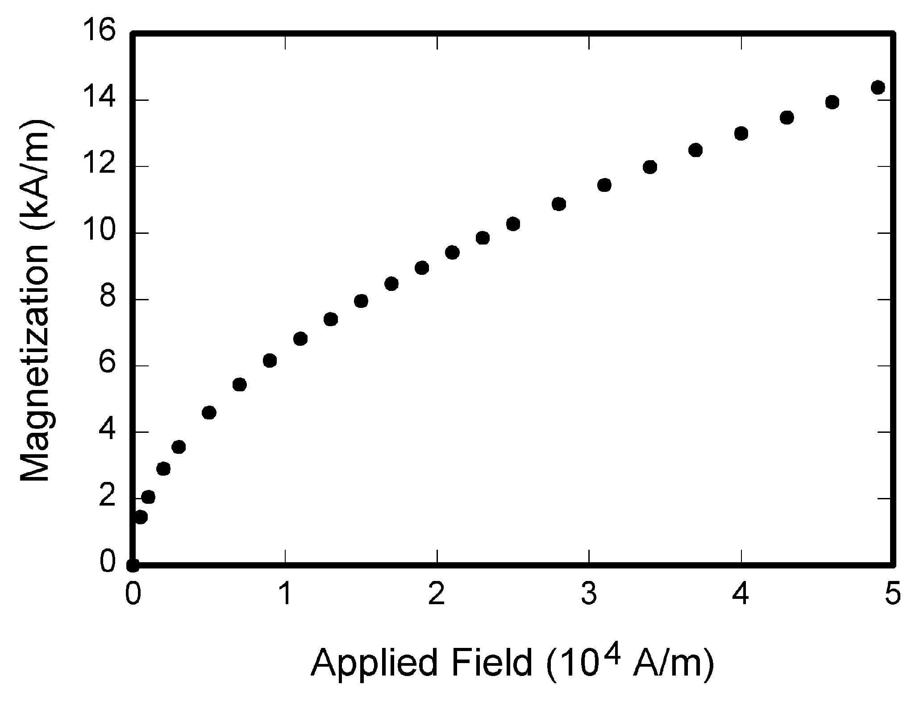
Fig. 1. Magnetization as a function of applied field. Note that “Fig.” is abbreviated. There is a period after the figure number, followed by two spaces. It is good practice to explain the significance of the figure in the caption.

Conclusão
Descrever conclusão do trabalho.
Appendix
Appendixes, if needed, appear before the acknowledgment.
Acknowledgment
The preferred spelling of the word “acknowledgment” in American English is without an “e” after the “g.” Use the singular heading even if you have many acknowledgments. Avoid expressions such as “One of us (S.B.A.) would like to thank ... .” Instead, write “F. A. Author thanks ... .” In most cases, sponsor and financial support acknowledgments are placed in the unnumbered footnote on the first page, not here.
References and Footnotes

References
References need not be cited in text. When they are, they appear on the line, in square brackets, inside the punctuation. Multiple references are each numbered with separate brackets. When citing a section in a book, please give the relevant page numbers. In text, refer simply to the reference number. Do not use “Ref.” or “reference” except at the beginning of a sentence: “Reference [3] shows ... .” Please do not use automatic endnotes in Word, rather, type the reference list at the end of the paper using the “References” style.
Reference numbers are set flush left and form a column of their own, hanging out beyond the body of the reference. The reference numbers are on the line, enclosed in square brackets. In all references, the given name of the author or editor is abbreviated to the initial only and precedes the last name. Use them all; use et al. only if names are not given. Use commas around Jr., Sr., and III in names. Abbreviate conference titles. When citing IEEE transactions, provide the issue number, page range, volume number, year, and/or month if available. When referencing a patent, provide the day and the month of issue, or application. References may not include all information; please obtain and include relevant information. Do not combine references. There must be only one reference with each number. If there is a URL included with the print reference, it can be included at the end of the reference.
Other than books, capitalize only the first word in a paper title, except for proper nouns and element symbols. For papers published in translation journals, please give the English citation first, followed by the original foreign-language citation See the end of this document for formats and examples of common references. For a complete discussion of references and their formats, see the IEEE style manual at www.ieee.org/authortools.

Footnotes
Number footnotes separately in superscripts (Insert | Footnote). Place the actual footnote at the bottom of the column in which it is cited; do not put footnotes in the reference list (endnotes). Use letters for table footnotes (see Table I).

References

Basic format for books:
J. K. Author, “Title of chapter in the book,” in Title of His Published Book, xth ed. City of Publisher, (only U.S. State), Country: Abbrev. of Publisher, year, ch. x, sec. x, pp. xxx–xxx.
Examples:
- G. O. Young, “Synthetic structure of industrial plastics,” in Plastics, 2nd ed., vol. 3, J. Peters, Ed. New York, NY, USA: McGraw-Hill, 1964, pp. 15–64.
- W.-K. Chen, Linear Networks and Systems. Belmont, CA, USA: Wadsworth, 1993, pp. 123–135.

Basic format for periodicals:
J. K. Author, “Name of paper,” Abbrev. Title of Periodical, vol. x, no. x, pp. xxx-xxx, Abbrev. Month, year, DOI. 10.1109.XXX.123456.
Examples:
- J. U. Duncombe, “Infrared navigation—Part I: An assessment of feasibility,” IEEE Trans. Electron Devices, vol. ED-11, no. 1, pp. 34–39, Jan. 1959, 10.1109/TED.2016.2628402.
- E. P. Wigner, “Theory of traveling-wave optical laser,”
Phys. Rev.,
vol. 134, pp. A635–A646, Dec. 1965.
- E. H. Miller, “A note on reflector arrays,” IEEE Trans. Antennas Propagat., to be published.

Basic format for reports:
J. K. Author, “Title of report,” Abbrev. Name of Co., City of Co., Abbrev. State, Country, Rep. xxx, year.
Examples:
- E. E. Reber, R. L. Michell, and C. J. Carter, “Oxygen absorption in the earth’s atmosphere,” Aerospace Corp., Los Angeles, CA, USA, Tech. Rep. TR-0200 (4230-46)-3, Nov. 1988.
- J. H. Davis and J. R. Cogdell, “Calibration program for the 16-foot antenna,” Elect. Eng. Res. Lab., Univ. Texas, Austin, TX, USA, Tech. Memo. NGL-006-69-3, Nov. 15, 1987.

Basic format for handbooks:
Name of Manual/Handbook, x ed., Abbrev. Name of Co., City of Co., Abbrev. State, Country, year, pp. xxx-xxx.
Examples:
- Transmission Systems for Communications, 3rd ed., Western Electric Co., Winston-Salem, NC, USA, 1985, pp. 44–60.
- Motorola Semiconductor Data Manual, Motorola Semiconductor Products Inc., Phoenix, AZ, USA, 1989.

Basic format for books (when available online):
J. K. Author, “Title of chapter in the book,” in Title of Published Book, xth ed. City of Publisher, State, Country: Abbrev. of Publisher, year, ch. x, sec. x, pp. xxx–xxx. [Online]. Available: http://www.web.com
Examples:
- G. O. Young, “Synthetic structure of industrial plastics,” in Plastics, vol. 3, Polymers of Hexadromicon, J. Peters, Ed., 2nd ed. New York, NY, USA: McGraw-Hill, 1964, pp. 15-64. [Online]. Available: http://www.bookref.com.
- The Founders’ Constitution, Philip B. Kurland and Ralph Lerner, eds., Chicago, IL, USA: Univ. Chicago Press, 1987. [Online]. Available: http://press-pubs.uchicago.edu/founders/
- The Terahertz Wave eBook. ZOmega Terahertz Corp., 2014. [Online]. Available: http://dl.z-thz.com/eBook/zomega_ebook_pdf_1206_sr.pdf. Accessed on: May 19, 2014.
- Philip B. Kurland and Ralph Lerner, eds., The Founders’ Constitution. Chicago, IL, USA: Univ. of Chicago Press, 1987, Accessed on: Feb. 28, 2010, [Online] Available: http://press-pubs.uchicago.edu/founders/

Basic format for journals (when available online):
J. K. Author, “Name of paper,” Abbrev. Title of Periodical, vol. x, no. x, pp. xxx-xxx, Abbrev. Month, year. Accessed on: Month, Day, year, DOI: 10.1109.XXX.123456, [Online].
Examples:
- J. S. Turner, “New directions in communications,” IEEE J. Sel. Areas Commun., vol. 13, no. 1, pp. 11-23, Jan. 1995.
- W. P. Risk, G. S. Kino, and H. J. Shaw, “Fiber-optic frequency shifter using a surface acoustic wave incident at an oblique angle,” Opt. Lett., vol. 11, no. 2, pp. 115–117, Feb. 1986.
- P. Kopyt et al., “Electric properties of graphene-based conductive layers from DC up to terahertz range,” IEEE THz Sci. Technol., to be published. DOI: 10.1109/TTHZ.2016.2544142.

Basic format for papers presented at conferences (when available online):
J.K. Author. (year, month). Title. presented at abbrev. conference title. [Type of Medium]. Available: site/path/file
Example:
- PROCESS Corporation, Boston, MA, USA. Intranets: Internet technologies deployed behind the firewall for corporate productivity. Presented at INET96 Annual Meeting. [Online]. Available: http://home.process.com/Intranets/wp2.htp

Basic format for reports and handbooks (when available online):
J. K. Author. “Title of report,” Company. City, State, Country. Rep. no., (optional: vol./issue), Date. [Online] Available: site/path/file
Examples:
- R. J. Hijmans and J. van Etten, “Raster: Geographic analysis and modeling with raster data,” R Package Version 2.0-12, Jan. 12, 2012. [Online]. Available: http://CRAN.R-project.org/package=raster
- Teralyzer. Lytera UG, Kirchhain, Germany [Online]. Available: http://www.lytera.de/Terahertz_THz_Spectroscopy.php?id=home, Accessed on: Jun. 5, 2014

Basic format for computer programs and electronic documents (when available online):
Legislative body. Number of Congress, Session. (year, month day). Number of bill or resolution, Title. [Type of medium]. Available: site/path/file
NOTE: ISO recommends that capitalization follow the accepted practice for the language or script in which the information is given.
Example:
- U.S. House. 102nd Congress, 1st Session. (1991, Jan. 11). H. Con. Res. 1, Sense of the Congress on Approval of Military Action. [Online]. Available: LEXIS Library: GENFED File: BILLS

Basic format for patents (when available online):
Name of the invention, by inventor’s name. (year, month day). Patent Number [Type of medium]. Available: site/path/file
Example:
- Musical toothbrush with mirror, by L.M.R. Brooks. (1992, May 19). Patent D 326 189
[Online]. Available: NEXIS Library: LEXPAT File: DES

Basic format for conference proceedings (published):
J. K. Author, “Title of paper,” in Abbreviated Name of Conf., City of Conf., Abbrev. State (if given), Country, year, pp. xxxxxx.
Example:
- D. B. Payne and J. R. Stern, “Wavelength-switched pas- sively coupled single-mode optical network,” in Proc. IOOC-ECOC, Boston, MA, USA, 1985,
pp. 585–590.
Example for papers presented at conferences (unpublished):
- D. Ebehard and E. Voges, “Digital single sideband detection for interferometric sensors,” presented at the 2nd Int. Conf. Optical Fiber Sensors, Stuttgart, Germany, Jan. 2-5, 1984.

Basic format for patents:
J. K. Author, “Title of patent,” U.S. Patent x xxx xxx, Abbrev. Month, day, year.
Example:
- G. Brandli and M. Dick, “Alternating current fed power supply,” U.S. Patent 4 084 217, Nov. 4, 1978.
Basic format for theses (M.S.) and dissertations (Ph.D.):
a) J. K. Author, “Title of thesis,” M.S. thesis, Abbrev. Dept., Abbrev. Univ., City of Univ., Abbrev. State, year.
b) J. K. Author, “Title of dissertation,” Ph.D. dissertation, Abbrev. Dept., Abbrev. Univ., City of Univ., Abbrev. State, year.
Examples:
- J. O. Williams, “Narrow-band analyzer,” Ph.D. dissertation, Dept. Elect. Eng., Harvard Univ., Cambridge, MA, USA, 1993.
- N. Kawasaki, “Parametric study of thermal and chemical nonequilibrium nozzle flow,” M.S. thesis, Dept. Electron. Eng., Osaka Univ., Osaka, Japan, 1993.
Basic format for the most common types of unpublished references:
a) J. K. Author, private communication, Abbrev. Month, year.
b) J. K. Author, “Title of paper,” unpublished.
c) J. K. Author, “Title of paper,” to be published.
Examples:
- A. Harrison, private communication, May 1995.
- B. Smith, “An approach to graphs of linear forms,” unpublished.
- A. Brahms, “Representation error for real numbers in binary computer arithmetic,” IEEE Computer Group Repository, Paper R-67-85.

Basic formats for standards:
a) Title of Standard, Standard number, date.
b) Title of Standard, Standard number, Corporate author, location, date.
Examples:
- IEEE Criteria for Class IE Electric Systems, IEEE Standard 308, 1969.
- Letter Symbols for Quantities, ANSI Standard Y10.5-1968.

Article number in reference examples:
- R. Fardel, M. Nagel, F. Nuesch, T. Lippert, and A. Wokaun, “Fabrication of organic light emitting diode pixels by laser-assisted forward transfer,” Appl. Phys. Lett., vol. 91, no. 6, Aug. 2007, Art. no. 061103.
- J. Zhang and N. Tansu, “Optical gain and laser characteristics of InGaN quantum wells on ternary InGaN substrates,” IEEE Photon. J., vol. 5, no. 2, Apr. 2013, Art. no. 2600111

Example when using et al.:
- S. Azodolmolky et al., Experimental demonstration of an impairment aware network planning and operation tool for transparent/translucent optical networks,” J. Lightw. Technol., vol. 29, no. 4, pp. 439–448, Sep. 2011.

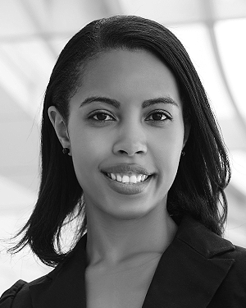
First A. Author (M’76–SM’81–F’87) and all authors may include biographies. Biographies are often not included in conference-related papers. This author became a Member (M) of IEEE in 1976, a Senior Member (SM) in 1981, and a Fellow (F) in 1987. The first paragraph may contain a place and/or date of birth (list place, then date). Next, the author’s educational background is listed. The degrees should be listed with type of degree in what field, which institution, city, state, and country, and year the degree was earned. The author’s major field of study should be lower-cased.
The second paragraph uses the pronoun of the person (he or she) and not the author’s last name. It lists military and work experience, including summer and fellowship jobs. Job titles are capitalized. The current job must have a location; previous positions may be listed without one. Information concerning previous publications may be included. Try not to list more than three books or published articles. The format for listing publishers of a book within the biography is: title of book (publisher name, year) similar to a reference. Current and previous research interests end the paragraph.
The third paragraph begins with the author’s title and last name (e.g., Dr. Smith, Prof. Jones, Mr. Kajor, Ms. Hunter). List any memberships in professional societies other than the IEEE. Finally, list any awards and work for IEEE committees and publications. If a photograph is provided, it should be of good quality, and professional-looking. Following are two examples of an author’s biography.

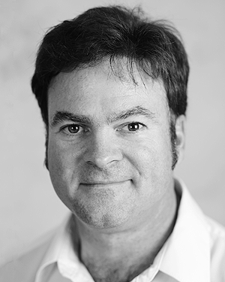
Second B. Author was born in Greenwich Village, New York, NY, USA in 1977. He received the B.S. and M.S. degrees in aerospace engineering from the University of Virginia, Charlottesville, in 2001 and the Ph.D. degree in mechanical engineering from Drexel University, Philadelphia, PA, in 2008.
From 2001 to 2004, he was a Research Assistant with the Princeton Plasma Physics Laboratory. Since 2009, he has been an Assistant Professor with the Mechanical Engineering Department, Texas A&M University, College Station. He is the author of three books, more than 150 articles, and more than 70 inventions. His research interests include high-pressure and high-density nonthermal plasma discharge processes and applications, microscale plasma discharges, discharges in liquids, spectroscopic diagnostics, plasma propulsion, and innovation plasma applications. He is an Associate Editor of the journal Earth, Moon, Planets, and holds two patents.
Dr. Author was a recipient of the International Association of Geomagnetism and Aeronomy Young Scientist Award for Excellence in 2008, and the IEEE Electromagnetic Compatibility Society Best Symposium Paper Award in 2011.

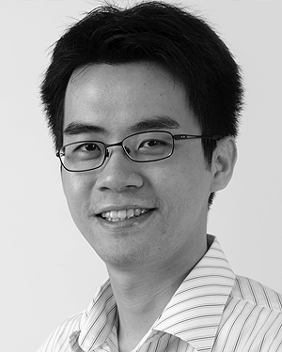
Third C. Author, Jr. (M’87) received the B.S. degree in mechanical engineering from National Chung Cheng University, Chiayi, Taiwan, in 2004 and the M.S. degree in mechanical engineering from National Tsing Hua University, Hsinchu, Taiwan, in 2006. He is currently pursuing the Ph.D. degree in mechanical engineering at Texas A&M University, College Station, TX, USA.
From 2008 to 2009, he was a Research Assistant with the Institute of Physics, Academia Sinica, Tapei, Taiwan. His research interest includes the development of surface processing and biological/medical treatment techniques using nonthermal atmospheric pressure plasmas, fundamental study of plasma sources, and fabrication of micro- or nanostructured surfaces.
Mr. Author’s awards and honors include the Frew Fellowship (Australian Academy of Science), the I. I. Rabi Prize (APS), the European Frequency and Time Forum Award, the Carl Zeiss Research Award, the William F. Meggers Award and the Adolph Lomb Medal (OSA).

 Este trabalho foi apresentado para revisão pela banca examinadora em XX/XX/XX e apresentado no dia XX/XX/XX na Escola de Engenharia da UFF, sala XX, bloco XX. (NOME DO ALUNO) é aluno do XX período do curso de graduação em Engenharia Elétrica da UFF (E DEMAIS QUALIFICAÇÕES PERTINENTES – trabalha na empresa XXX, é aluno da Tesla Jr, do PET, do Barco Solar, Carro Elétrico, Ramo Estudantil, etc) (e-mail: ALUNO@id.uff.br). (NOME DO ORIENTADOR) é professor do Departamento de Engenharia Elétrica da UFF (E DEMAIS QUALIFICAÇÕES PERTINENTES) (e-mail: PROFESSOR@id.uff.br). (NOME DO CO-ORIENTADOR) é QUALIFICAÇÃO PERTINENTE) (e-mail: COORIENTADOR@xxx.xxx.xxx).
It is recommended that footnotes be avoided (except for the unnumbered footnote with the receipt date on the first page). Instead, try to integrate the footnote information into the text.

